|  |  |  |
| --- | --- | --- |
| SCHOOL OF INFORMATION AND TECHNOLOGY | | |
| NAME:  Padilla, Arvin Macaraeg, Jake | DATE PERFORMED: 12/4/24 | /50 |
| Section: IDC2 | DATE SUBMITTED: |

# SYSADM1 – Capacity Management & Planning

# Part 2. Network Scalability Analysis

Recall the e-commerce website scenario we discussed earlier. Given the expected surge in traffic, analyze the provided network topology diagram. Identify potential bottlenecks and areas where scalability might be a concern. Propose specific strategies to improve the network's scalability and performance to ensure a seamless user experience during the peak traffic period. Consider factors such as increased user demand, new applications, and security threats.



**Bottlenecks and Scalability Concerns**

Key concerns include the central server's capacity to handle high traffic, with potential struggles arising from insufficient processing power, memory, or storage. Network switches and routers could become chokepoints due to limited bandwidth or outdated protocols, while poorly configured load balancers may cause uneven traffic distribution. Database scalability is another issue, as growing demand can lead to latency or downtime without horizontal or vertical scaling. Additionally, increased traffic heightens security risks, such as DDoS attacks or unauthorized access, necessitating robust protective measures.

**Proposed Scalability Strategies**

To address these bottlenecks, several strategies can be implemented. First, upgrading the server hardware, such as adding more CPU cores, increasing memory, or employing faster solid-state drives (SSDs), can directly enhance performance. Implementing a distributed architecture with multiple servers can also mitigate risks of overload by enabling horizontal scaling.

For network switches and routers, upgrading to high-bandwidth devices or incorporating Software-Defined Networking can improve traffic management and flexibility. Load balancers should be enhanced with auto-scaling features and advanced algorithms to ensure an even distribution of traffic.

**Evaluation of Proposed Solutions**

While these strategies promise significant benefits, they also come with trade-offs. Hardware upgrades, while effective, can be costly and require downtime for implementation. Cloud migration provides flexibility but involves ongoing costs and potential security risks. Advanced load balancers and SDN setups may demand specialized expertise and additional configuration time.

**Proposed Design and Justification**

A comprehensive design to accommodate the expected traffic surge should include a combination of horizontal scaling for servers, a robust load-balancing mechanism, and enhanced security measures like firewalls and intrusion detection systems. It should also integrate a hybrid cloud model to balance on-premises and cloud-based resources for optimal cost and scalability.

Considering cost, complexity, and impact, the proposed solutions are justifiable for ensuring long-term performance and reliability. The trade-offs, while notable, are outweighed by the benefits of a seamless and secure user experience, particularly during peak periods.

**IMPROVED NETWORK DIAGRAM:**

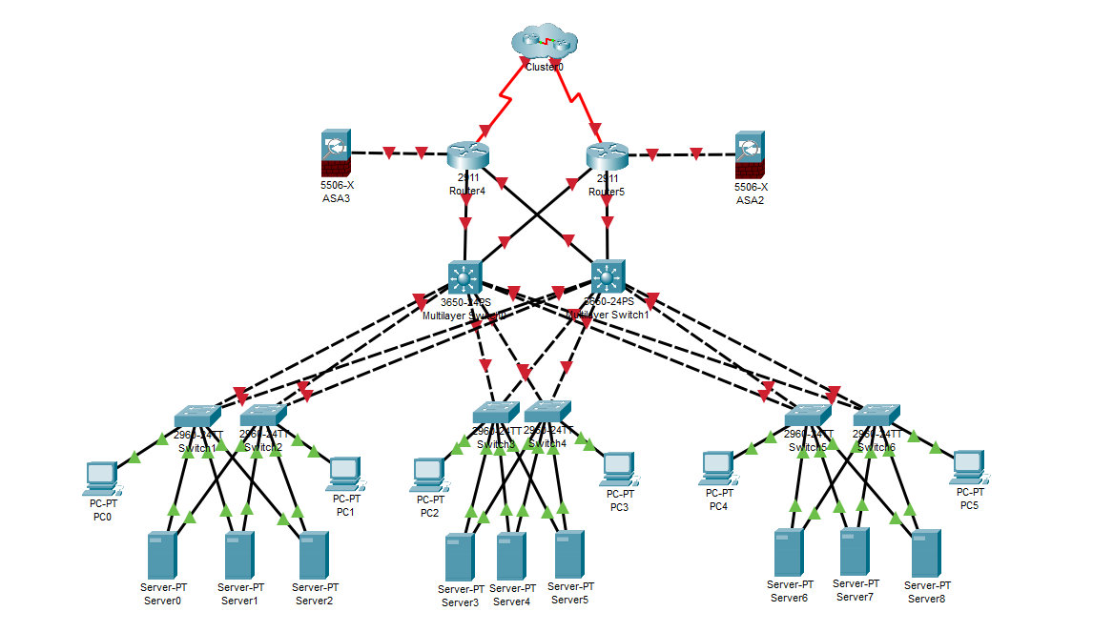

|  |  |  |  |
| --- | --- | --- | --- |
| Criteria | Excellent | 10pts | Good | 7pts | Needs Improvement | 4pts |
| **Network Analysis** | Accurately identifies potential bottlenecks, security risks, and capacity limitations. | Identifies key network components and some potential bottlenecks. | Identifies some basic network components but lacks a comprehensive analysis. |
| **Scalability Planning** | Proposes multiple relevant solutions and provides detailed explanations, including potential drawbacks and benefits. | Proposes some relevant scalability strategies but lacks detail. | Proposes limited scalability strategies. |
| **Evaluation of Solutions** | Proposes comprehensive scalability strategies, including specific recommendations for hardware upgrades, software configurations, and network optimizations. | Provides a basic evaluation of the proposed solutions, but lacks depth. | Does not evaluate the proposed solutions or provides a superficial evaluation. |
| **Proposed Design** | Provides a detailed and well-justified design, including network diagrams, configuration details, and implementation plans. | Provides a basic design but lacks specific details and justifications. | Does not provide a clear and detailed design. |
| **Evaluation and Justification** | Provides a thorough evaluation of the proposed solutions, considering factors like cost, complexity, and potential impact. | Provides a basic evaluation of the proposed solutions, but lacks depth. | Does not evaluate the proposed solutions or provides a superficial evaluation |
| Score: | | | /50 |